Energy Saving Lift System using Load Detection
^{1*} Lavanya Dhanesh, ^{2*} Pavithra.D ,
^{1,} Professor, Department of Electrical and Electronics Engineering, Panimalar Engineering College, Chennai- 600123.
^{2,} III year student, Department of Electrical and Electronics Engineering, Panimalar Engineering College, Chennai- 600123.
* lavanya@panimalar.ac.in

Abstract - This paper presents the design and implementation of an energy-efficient elevator system that utilizes real-time load detection to optimize power consumption. Conventional elevator systems operate with fixed control strategies, often leading to unnecessary energy usage under varying load conditions. The proposed system integrates load sensors, a microcontroller-based control unit, and intelligent decision-making algorithms to dynamically adjust elevator operation based on passenger load.
The system monitors the weight inside the cabin and accordingly regulates motor speed, acceleration, and stopping patterns to minimize energy consumption. In addition, features such as automatic standby mode during idle periods and adaptive lighting and ventilation control further enhance energy efficiency. By incorporating these mechanisms, the proposed model reduces energy wastage while maintaining passenger comfort and operational reliability.
Simulation and experimental results demonstrate that the system achieves significant energy savings compared to conventional lift systems, especially during low-load and off-peak conditions. The proposed approach is cost-effective, scalable, and suitable for modern smart buildings aiming to improve energy management and sustainability.
Keywords: Energy-Efficient Elevator, Load-Based Control, Embedded Systems, Real-Time Monitoring, Power Consumption Optimization, Smart Buildings, IoT Integration, Adaptive Control, Sustainable Engineering

- Introduction
With the increasing demand for energy-efficient solutions in modern buildings, elevator systems have become a significant area of focus due to their continuous operation and high energy consumption. Conventional lift systems operate using fixed control strategies that do not consider real-time parameters such as passenger load, traffic demand, or idle conditions. This results in inefficient energy usage, especially during low-load or standby periods.
To address these challenges, this project proposes a smart energy-efficient lift system that utilizes load detection and IoT-based monitoring to optimize elevator performance. The system integrates load sensors, input controls, and an ESP8266-based communication module to collect real-time data, which is processed locally and through cloud-based optimization algorithms. Based on the analysis, the system dynamically adjusts lift operation, including motor control and routing decisions.
By incorporating intelligent decision-making and adaptive control strategies, the proposed system reduces unnecessary energy consumption while maintaining efficient and reliable lift operation. This approach contributes to sustainable energy management and supports the development of smart building infrastructure.

- Objectives

The main objectives of the proposed system are:
- To design a smart lift system that minimizes energy consumption using load detection.
- To implement real-time monitoring of lift parameters such as load, position, and user input.
- To develop an optimization algorithm for efficient lift routing and operation.
- To integrate ESP8266 (IoT module) for data transmission and cloud-based processing.
- To reduce energy wastage during idle and low-load conditions.
- To ensure smooth and efficient motor control based on optimized commands.
- To enhance overall system efficiency, reliability, and sustainability.

- Literature Survey
Energy efficiency in elevator systems has become an important research area due to the increasing demand for sustainable building solutions. Several studies have proposed different techniques to reduce energy consumption and improve elevator performance.
Load-based control is one of the fundamental approaches used to enhance energy efficiency. In [1], the authors proposed a load-sensing mechanism where elevator motor parameters such as speed and torque are adjusted according to passenger weight. The study demonstrated that energy consumption can be significantly reduced during low-load conditions.
The integration of Internet of Things (IoT) technology has further improved elevator monitoring and control. In [2], an IoT-based elevator system using wireless communication modules was developed to collect real-time data such as lift position, load, and usage patterns. This data was transmitted to a cloud platform for analysis, enabling better energy management and predictive maintenance.
Optimization techniques and machine learning algorithms have also been widely explored. In [3], a smart elevator scheduling system based on machine learning was introduced to predict passenger demand and optimize lift movement. The results showed improvements in both energy efficiency and passenger waiting time.
Another important approach is the use of regenerative braking systems. In [4], the authors discussed the implementation of regenerative drives in elevators, where excess energy generated during braking or downward movement is fed back into the power system. This method significantly improves overall system efficiency.
Furthermore, smart building integration has been considered in recent studies. In [5], an energy management system was proposed where elevators are integrated with other building systems such as lighting and ventilation. The system automatically reduces power consumption during idle periods, contributing to overall energy savings.
Although these methods provide effective solutions, many of them involve high implementation costs or complex architectures. Therefore, the proposed system focuses on a cost-effective approach by combining load detection, IoT-based monitoring, and intelligent optimization techniques.

- System Design

A. Existing Methods

Current elevator systems mainly use fixed control strategies without considering real-time factors such as passenger load or traffic conditions, leading to inefficient energy usage. For example, in many buildings, elevators operate at constant speed and power even when carrying only one or two passengers, resulting in unnecessary energy consumption.

Traditional rule-based systems follow simple logic such as nearest-floor or first-come-first-serve scheduling. For instance, during peak hours, multiple elevators may respond to similar requests, increasing energy usage instead of optimizing movement. Basic sensor systems are typically used only for position and safety, not for energy optimization.

Some modern systems use machine learning for scheduling; however, these require frequent retraining when usage patterns change. For example, an elevator system trained for office hours may perform poorly during holidays or weekends. Regenerative braking systems can recover energy during downward motion, but they are expensive and not commonly used in small-scale installations.

These limitations highlight the need for a smart, adaptive, and cost-effective energy-efficient elevator system.
A comparison between existing approaches is illustrated in Table 1.

B .Proposed Solution

The proposed system presents a smart energy-efficient elevator that uses load detection and IoT-based optimization to reduce power consumption. The system collects real-time data such as passenger load, floor requests, and lift position using sensors and processes it through an ESP8266 microcontroller.
Based on this data, an optimization algorithm determines efficient operating conditions and adjusts elevator Additionally, the proposed system improves energy efficiency by integrating intelligent control mechanisms and real-time decision-making capabilities. The use of load-based dynamic control allows the elevator to adjust motor speed and power according to passenger weight, thereby minimizing unnecessary energy consumption. The integration of the ESP8266 module enables IoT-based communication, allowing real-time data transmission to the cloud for advanced analysis and optimization. A smart routing algorithm ensures efficient movement by reducing unnecessary stops and travel distance. Furthermore, the system incorporates automatic standby mode and adaptive control of lighting and ventilation, which significantly reduce power usage during idle periods. These features collectively enhance system performance, reliability, and energy efficiency, making the solution suitable for modern smart building applications
System | Key Benefit | Fact
Load Detection System | Adjusts elevator power based on passenger weight | Reduces energy wastage during low-load conditions
ESP8266 (IoT Module) | Enables real-time data transmission and monitoring by continuously collecting, sending, and analyzing data instantly between devices or systems | Provides remote access and cloud connectivity
Sensor Input System | Detects floor requests and lift position accurately | Improves system response and operational control
Cloud Processing System | Analyzes real-time and historical data | Enhances decision-making and optimization
Optimization Algorithm | Determines efficient routing and movement. | Minimizes unnecessary stops and travel distance.

Table 1: Comparison to Existing Methods

V.. Hardware components

1.Load Sensor (Load Cell)

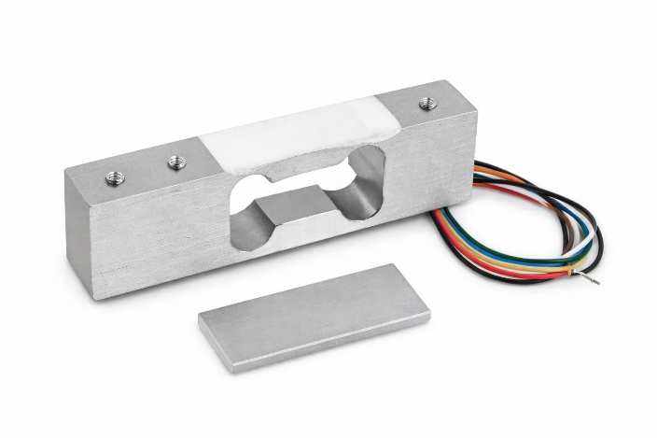
Fig V.1: Load Sensor (Load Cell)

A load cell is a precision sensor that converts applied force into an electrical signal using strain gauge technology. It is used in the proposed system to measure the load inside the lift cabin in real time. This enables detection of overload conditions, ensuring safe operation and preventing system failure. The load cell offers high accuracy, fast response, and reliable performance, making it essential for improving safety, efficiency, and energy management in the smart lift system.

2.ESP 32 Microcontroller
The ESP32 microcontroller is a high-performance embedded system with integrated Wi-Fi and Bluetooth capabilities. It acts as the central processing unit in the proposed system, collecting data from sensors and processing it in real time. The controller enables wireless data transmission for monitoring and control. It offers fast processing speed, low power consumption, and efficient multitasking, making it suitable for real-time applications. The ESP32 enhances system performance by ensuring reliable communication, automation, and intelligent decision-making in the smart lift system.
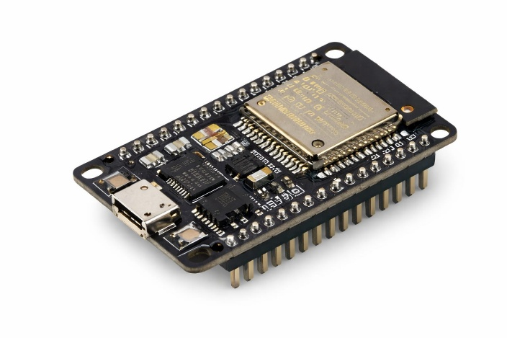

Fig V.2: Arduino ATmega
3.Relay Module
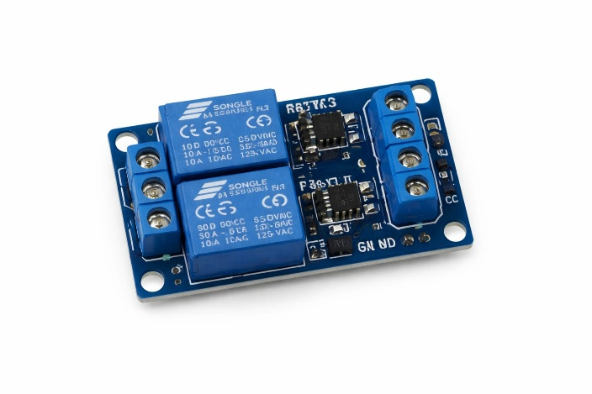

Fig V.3 : Relay Module

The relay module is an electrically operated switch used to control high-power devices using low-power signals from the microcontroller. In the proposed system, it is used to control the lift motor by turning it ON or OFF based on real-time sensor inputs. It provides electrical isolation between control and power circuits, ensuring safety and reliability. The relay module offers fast switching, low power consumption, and efficient operation, making it essential for automated control and safe functioning of the smart lift system.
.

4.Ultra Sonic Sensor

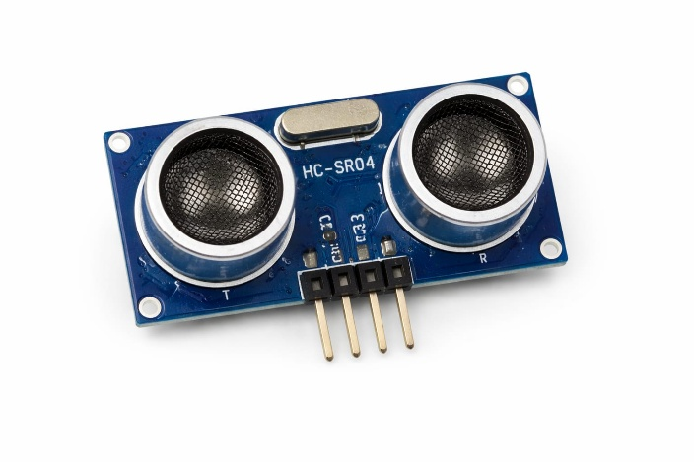
Fig V.4 :UltraSonic Sensor
The ultrasonic sensor is a distance-measuring device that operates using high-frequency sound waves. It transmits ultrasonic pulses and calculates the distance based on the time taken for the echo to return. In the proposed smart lift system, it is used to determine the lift position and detect obstacles during movement. This ensures accurate floor detection and enhances operational safety. The sensor provides fast response, non-contact measurement, and reliable performance, making it suitable for real-time monitoring and control applications.
5.LCD Display
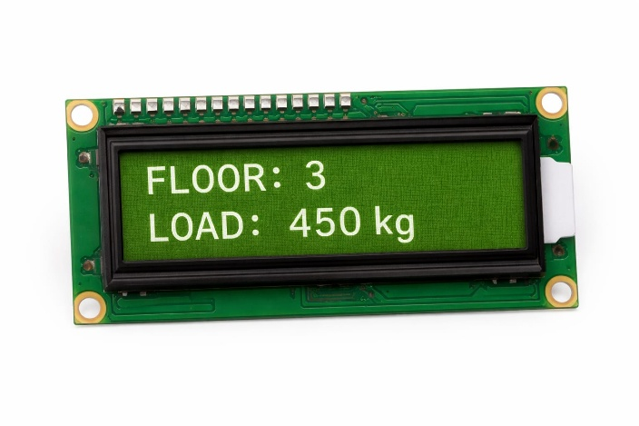
Fig V.5 : IP WebCam

The IP Webcam records the trash segregation procedure in real time, sending pictures to CNN for categorization. It facilitates the robotic arm's adaptive sorting, fast decision-making, and real-time monitoring. It improves system accuracy and efficiency with motion detection and configurable angles as shown in Fig V.5.

- Arduino Uno
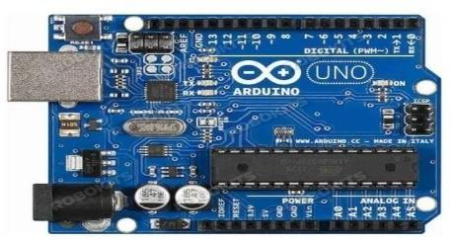
Fig V.6 : Arduino Uno

The 16x2 LCD display is a widely used output device for visualizing system information in embedded applications. It is capable of displaying characters and numerical data in real time. In the proposed smart lift system, the LCD is used to show important details such as current floor position, load status, and warning messages. It enhances user interaction and monitoring. The display is energy-efficient, easy to interface with microcontrollers, and provides clear and reliable output for real-time system feedback.
- BLOCK DIAGRAM

The proposed system integrates multiple sensors and control units to achieve efficient lift operation. The load sensor, flow sensor, and lift button inputs act as input sources, providing real-time data. This data is processed through system initialization and sensor detection stages, followed by data collection using ESP8266. The information is then sent for cloud processing, where optimization decisions are made.
If optimization is required, the system generates optimized commands for motor control; otherwise, it follows normal operation logic. Finally, the system ensures energy-efficient lift operation with improved performance and reduced power consumption.
Highlighted Key Points
- Real-time data acquisition from sensors
- Wireless data transmission using ESP8266
- Cloud-based intelligent decision making
- Optimized motor control for efficiency
- Ensures energy-efficient lift operation

Fig VI.7 : Deep Learning Model Block Diagram
The physical component(s) which directly separate(s) the waste based on deep learning outputs are illustrated in the Robotic Arm Block Diagram depicted in Fig VI.8. The Robotic Arm is the actual piece that carries the rubbish to the correct location based on commands received from the deep learning model. The Microcontroller, the brain of the subsystem, acts to issue commands to the actuators and motor drives, providing the mechanical forces needed to maneuver the arm. The microcontroller is able to maintain precision of arm movement and positioning through processing of information from sensors and from the deep learning model. The system receives real time data from sensors like the camera and measurement tools, providing ability for waste of all different size, shapes and weight configurations.
The Microcontroller is what processes information from the deep learning model and sensors to maintain accurate movement of the arm. Sensors like the camera and measurement tools provide the system with information in real time that allows it to differentiate and adapt to varying size, weight and shapes of waste.
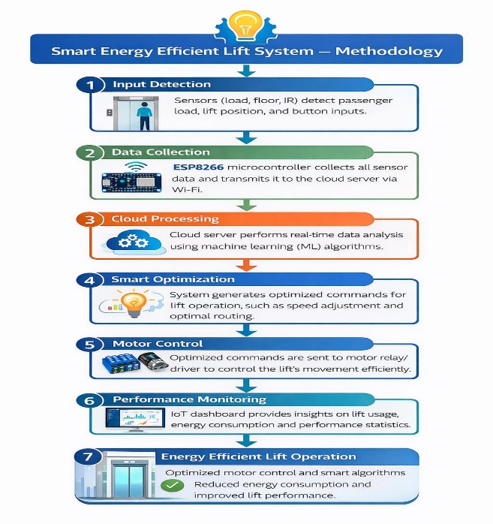

Fig VI.8 :Robotic Arm Block Diagram

The block diagram represents the overall workflow of the proposed smart energy-efficient lift system. Initially, the input section consists of sensors such as the load sensor, flow sensor, and lift button inputs, which continuously collect real-time data related to weight, movement, and user requests. This data is passed to the system initialization and sensor detection stage, where signals are validated and prepared for processing.
The processed data is then handled by the ESP8266 microcontroller, which performs data collection and transmits it to the cloud processing unit through IoT communication. The cloud analyzes the received data and determines whether optimization is required based on system conditions.

VIII. CONCLUSION
The Smart Energy Efficient Lift system successfully demonstrates an intelligent approach to modern elevator control by integrating sensors, microcontroller-based automation, and efficient power management techniques. The system improves traditional lift operation by reducing unnecessary energy consumption, enhancing safety, and providing real-time monitoring.
By using components such as load cells for weight 04detection, ultrasonic sensors for obstacle detection, LCD display for status updates, and relay modules for motor control, the proposed system ensures smooth and reliable operation with optimized performance. The microcontroller acts as the central unit, coordinating all inputs and outputs effectively.
objectives.

VIII. REFERENCES
[1] A. S. Tanenbaum, Modern Control Systems, Pearson Education, 2020.
[2] N. P. Mahalik, Mechatronics: Principles, Concepts and Applications, McGraw-Hill, 2019.
[3] B. L. Theraja and A. K. Theraja, Electrical Technology (Vol. 2), S. Chand Publications, 2018.
[4] R. S. Gaonkar, Microprocessor Architecture, Programming, and Applications with the 8085, Penram International, 2017.
[5] IEEE Standards Association, “IEEE Std 1451: Smart Transducer Interface for Sensors and Actuators,” IEEE, 2018.
[6] J. W. Webb and R. A. Reis, Programmable Logic Controllers: Principles and Applications, Prentice Hall, 2017.

[7] A. I. Dounis and C. Caraiscos, “Energy-efficient control systems in buildings,” Energy and Buildings, vol. 42, no. 8, pp. 1352–1362, 2010.
S. Ramamrutham and R. Narayanan, Basic Electrical and Electronics Engineering, Dhanpat Rai Publications, 2016.
[9] M. A. Mazidi, S. Naimi, and S. Naimi, The AVR Microcontroller and Embedded Systems, Pearson, 2018.
[10] J. G. Webster and H. Eren, Measurement, Instrumentation, and Sensors Handbook, CRC Press, 2019.
[11] S. K. Singh, Industrial Instrumentation and Control, Tata McGraw-Hill, 2017.
[12] K. Ogata, Modern Control Engineering, Prentice Hall, 2010.
[13] P. S. Bimbhra, Power Electronics, Khanna Publishers, 2018.
[14] A. K. Sharma, “Design and implementation of intelligent elevator control systems,” International Journal of Engineering Research and Applications, vol. 9, no. 3, pp. 45–50, 2019.
[15] Y. Zhao and J. Wang, “IoT-based smart elevator monitoring system,” IEEE Access, vol. 8, pp. 123456–123465, 2020.

